**VPC – Task 01**

* Create VPC with 2 private and 2 public subnets  
  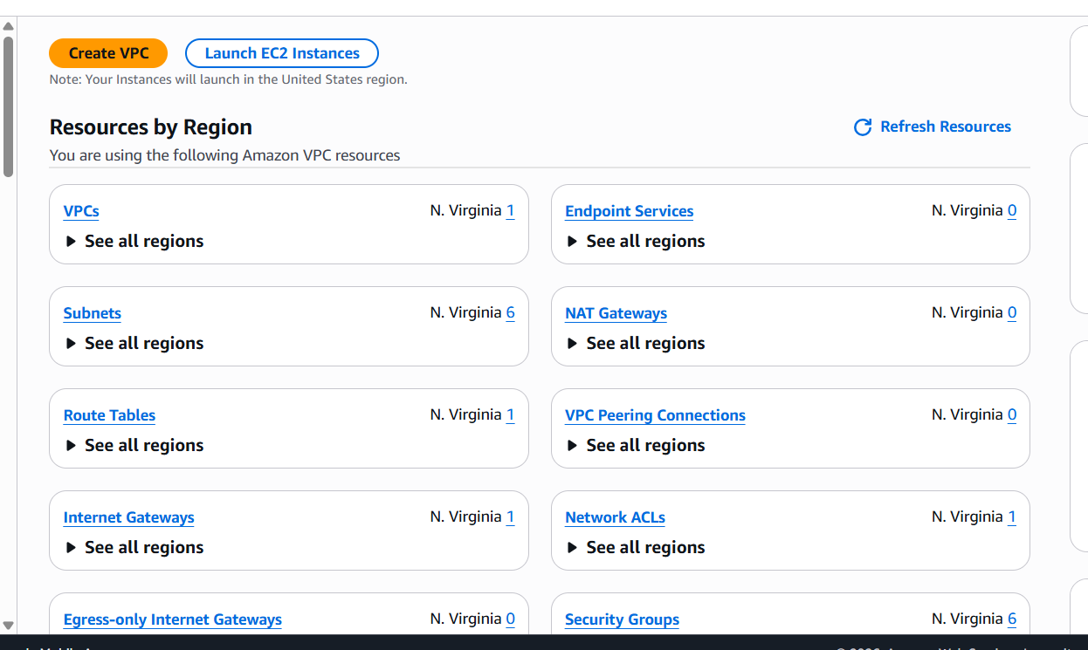  
  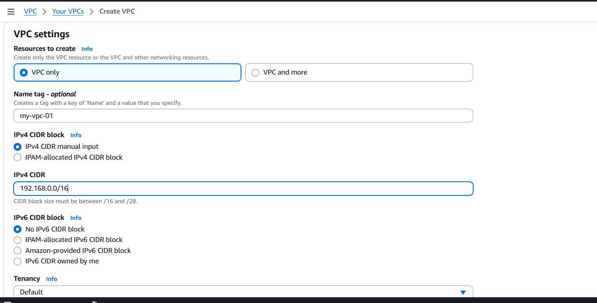  
  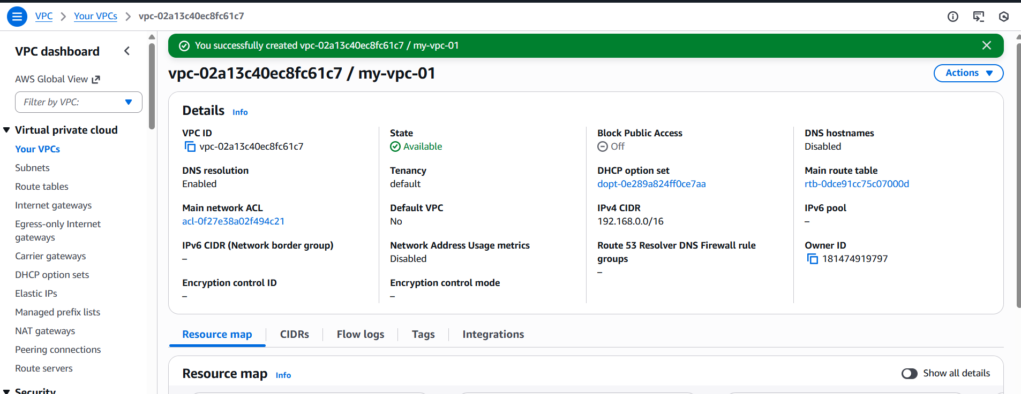  
  VPC created successfully, now we need to create 2 public subnets and 2 private subnets  
  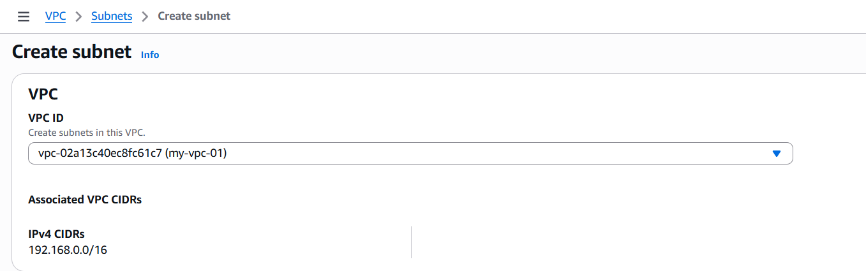  
  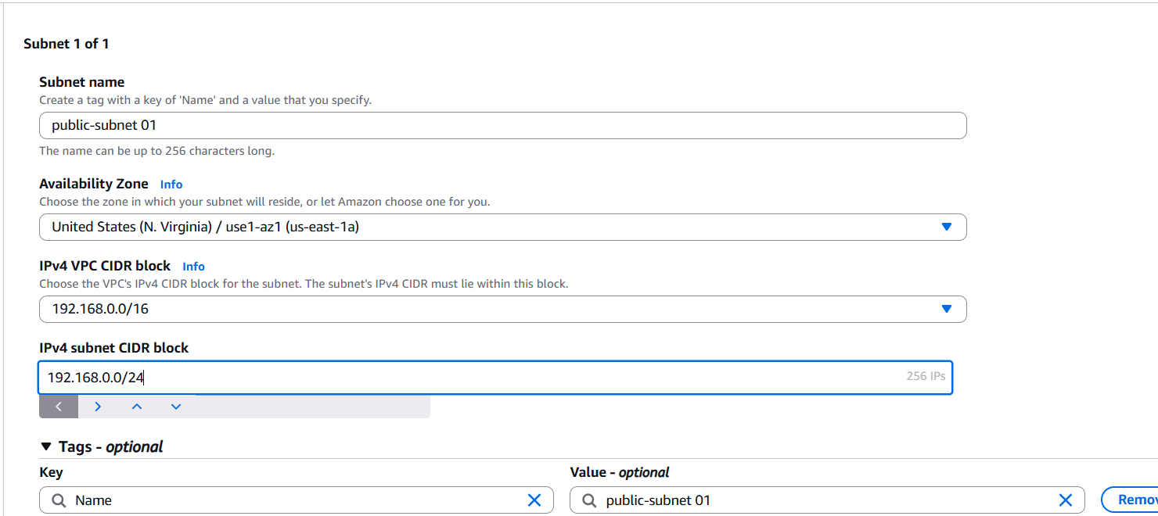  
  IPV4 Subnet CIDR block – 192.168.0.0/28  
  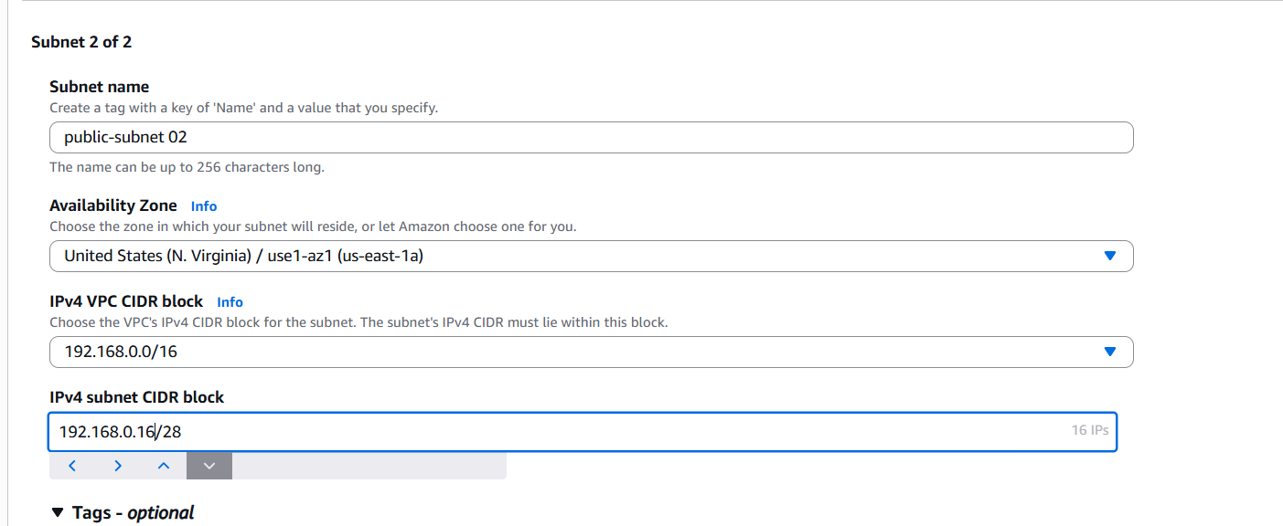  
  Private subnets  
  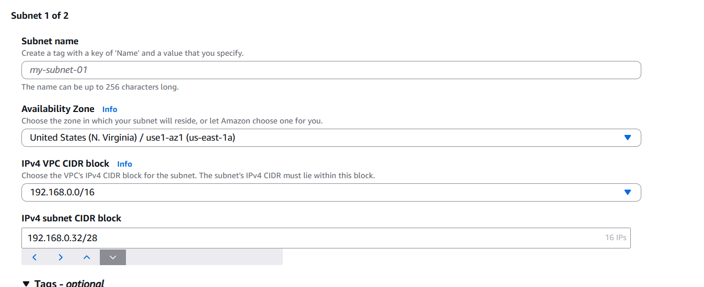  
  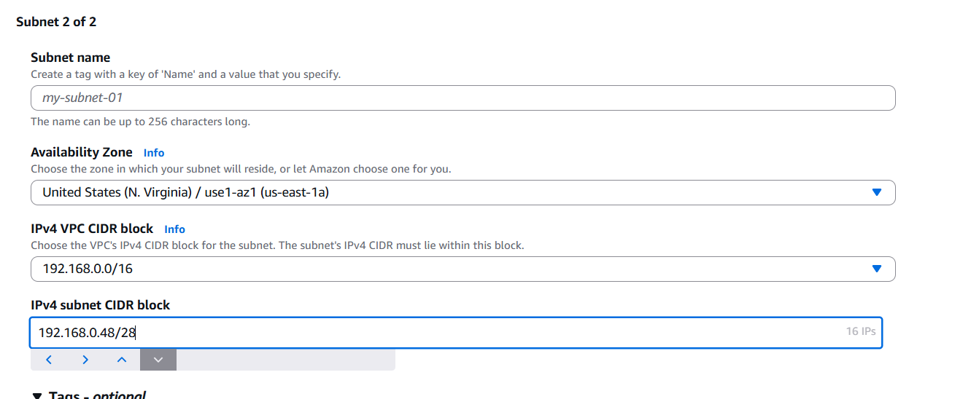  
  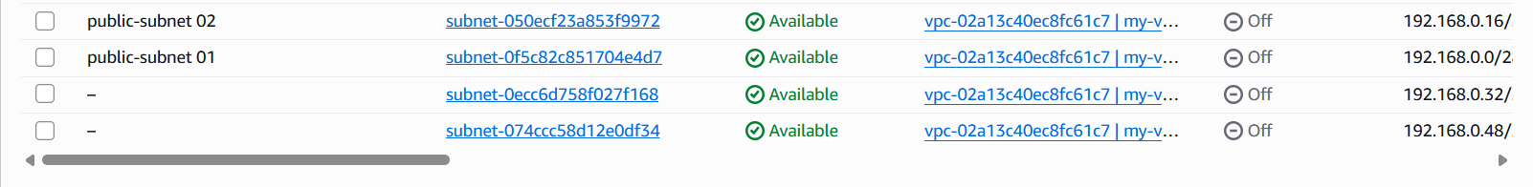
* Enable DNS Hostname in VPC  
  Search my vpc and click on actions and got vpc settings and you have option to enable dns hostname  
  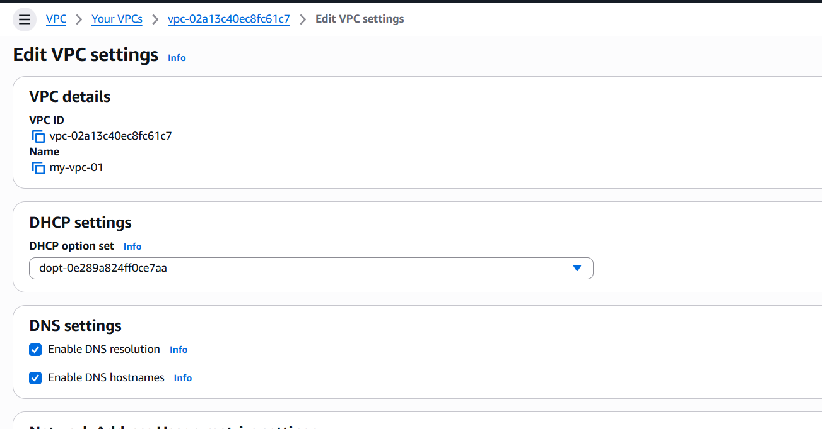  
  Click on save to successfully enable DNS hostnames
* Enable Auto Assign Public IP in 2 public subnets  
  Go to VPC click on subnets and click on created public subnet and go to actions and click on edit subnets there you will get auto assign public IP option  
  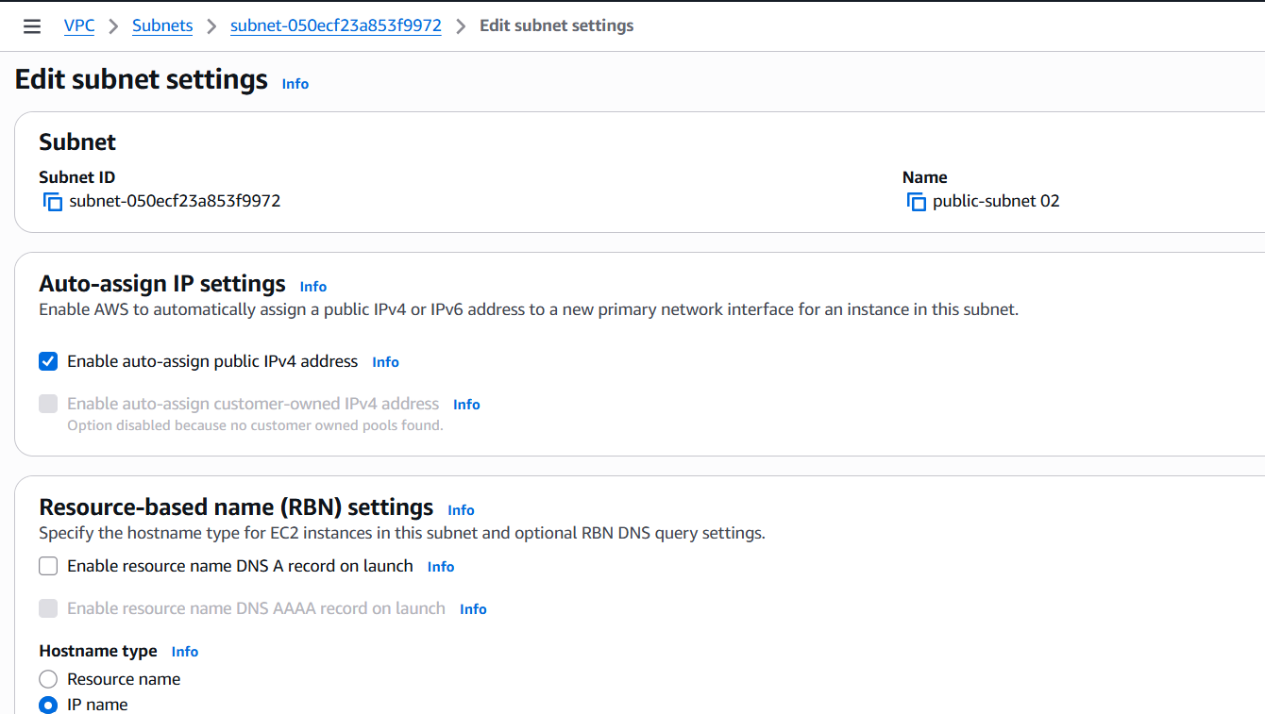  
  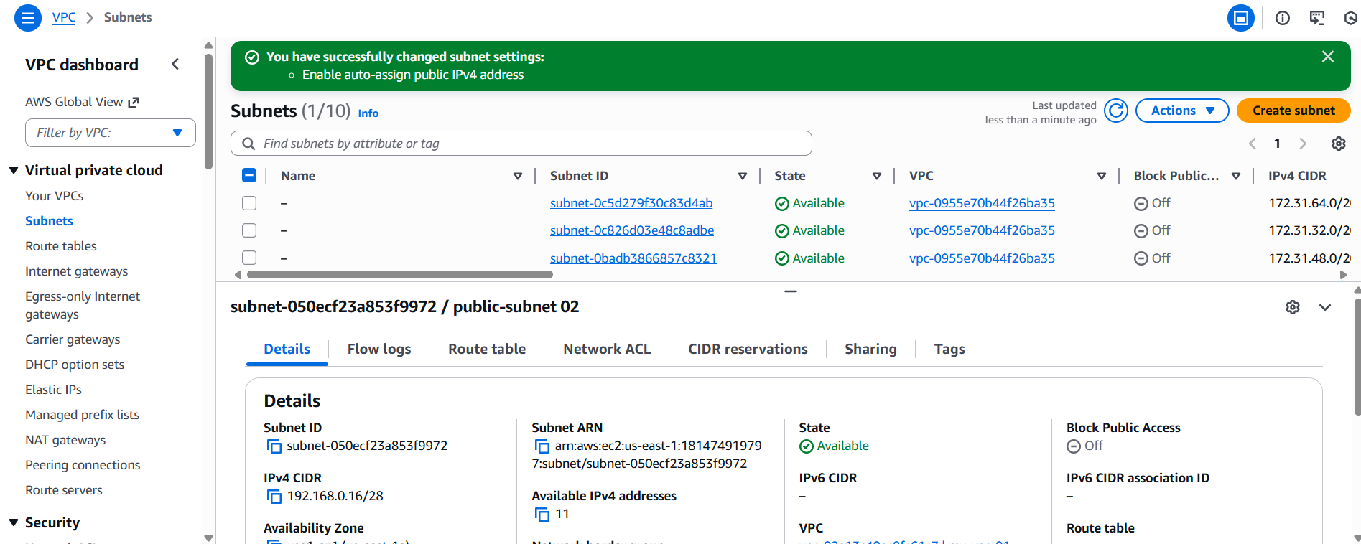  
  click on save, you have successfully enabled the option and same do for 2nd public subnet
* Add 2 private subnets in private route table  
  Go to VPC and select route table then click on create a route table and select VPC you want and click on create route table  
  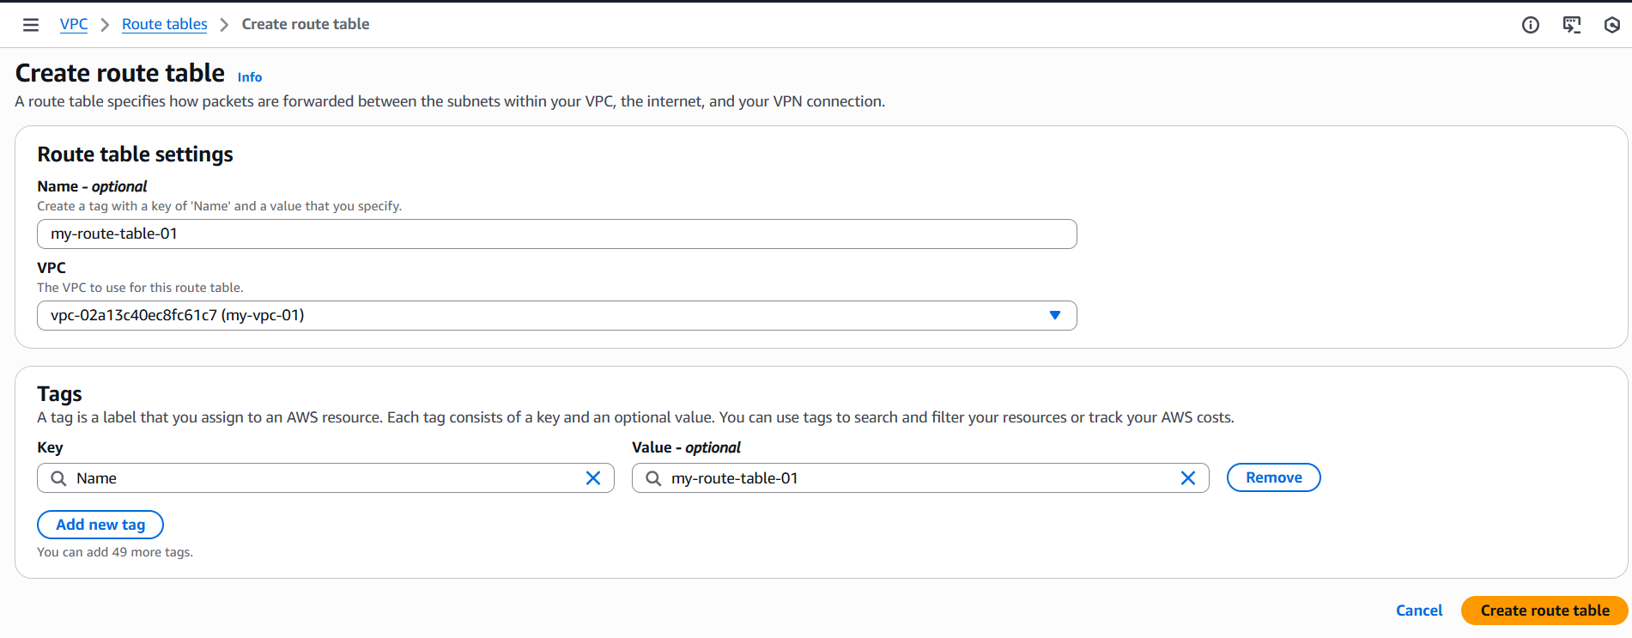  
  Click on edit subnet associations and click on 2 private subnets and save it  
  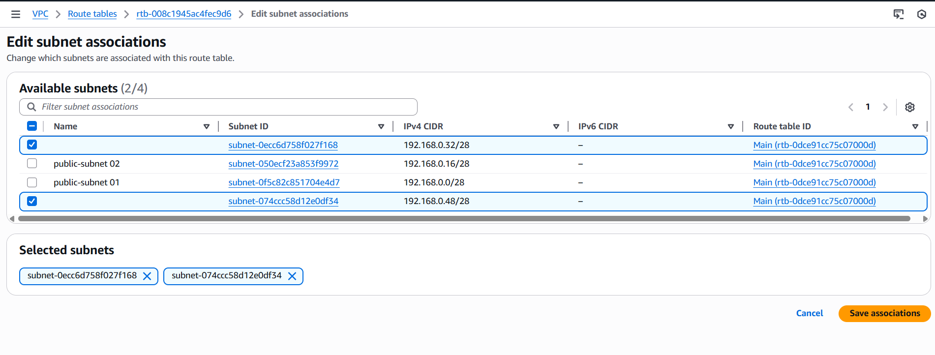  
  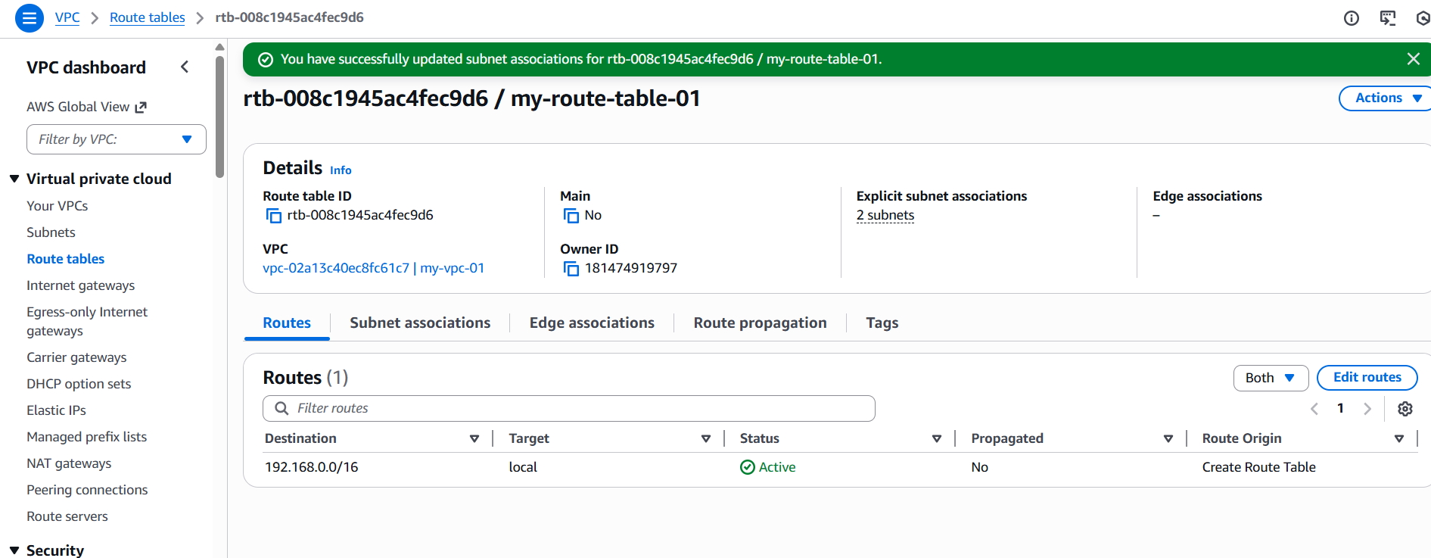
* Add 2 public subnets in public route table  
  Same as above to add 2 public subnets  
  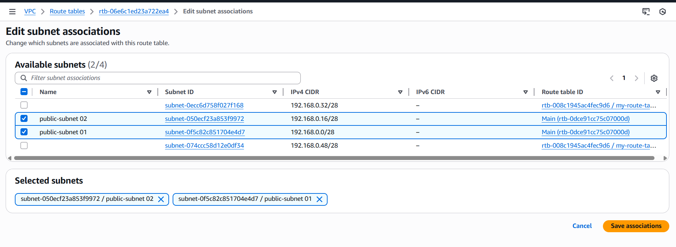  
  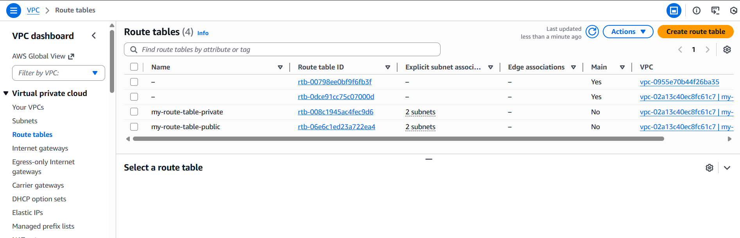
* Public route table will have the routes to internet and local  
  Firstly we need to create a Internet Gate way and add it our VPC

Go to VPC and search for internet gateway and click on it and create it   
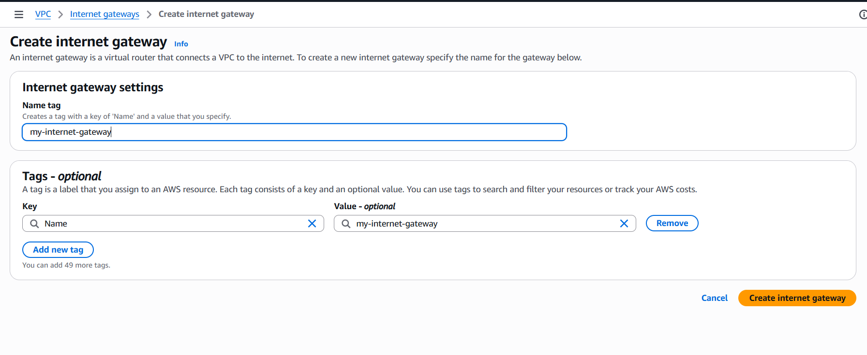  
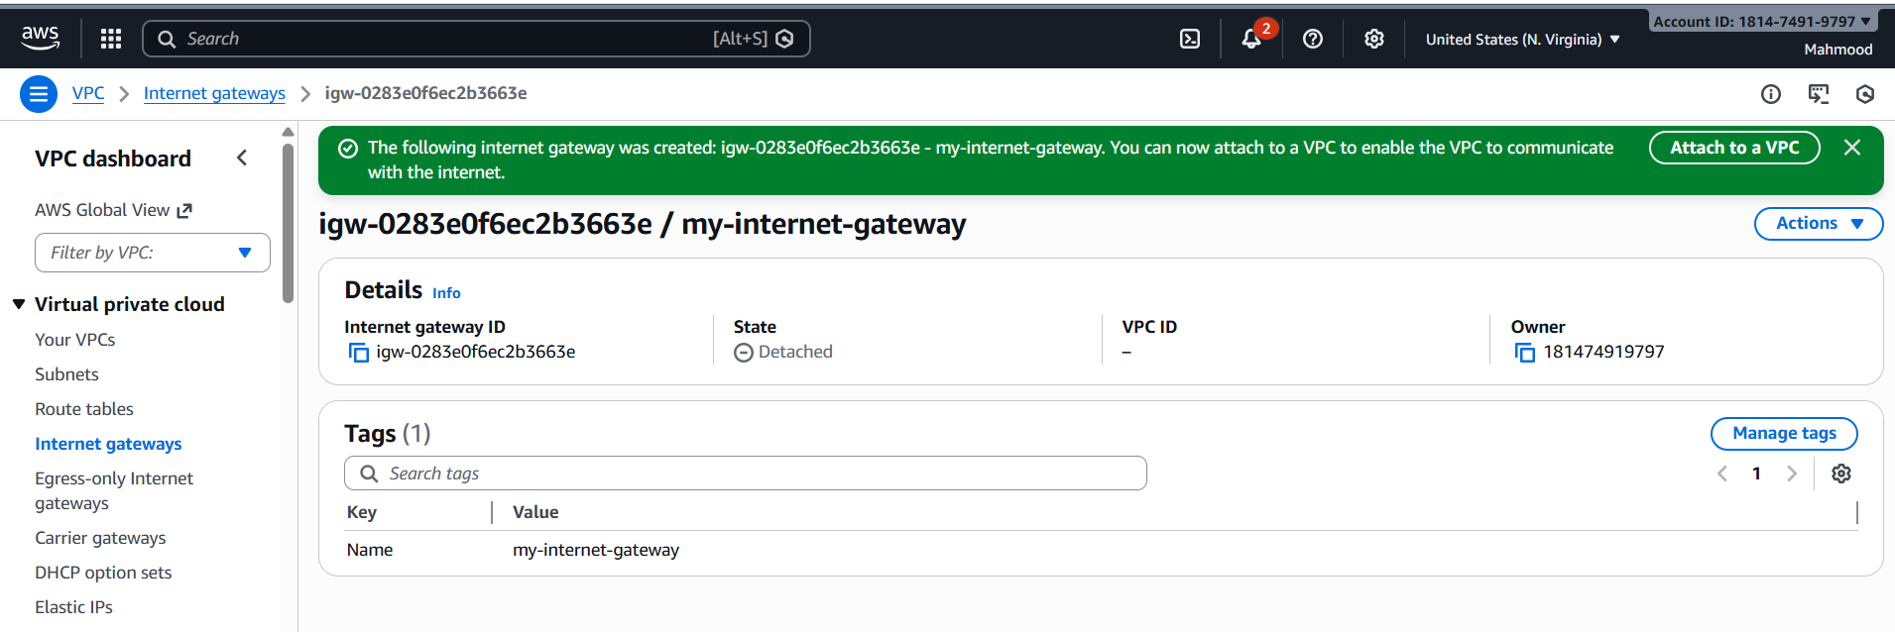  
and now attach internet gateway to VPC  
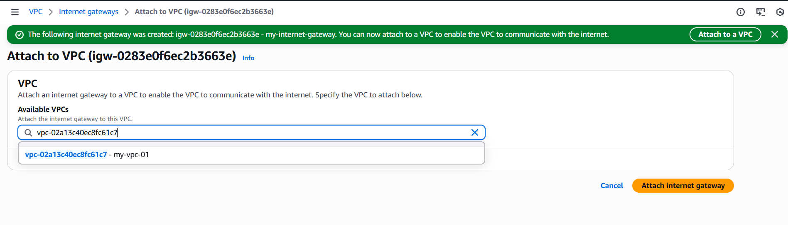  
Result you can see internet gateway is attached with VPC  
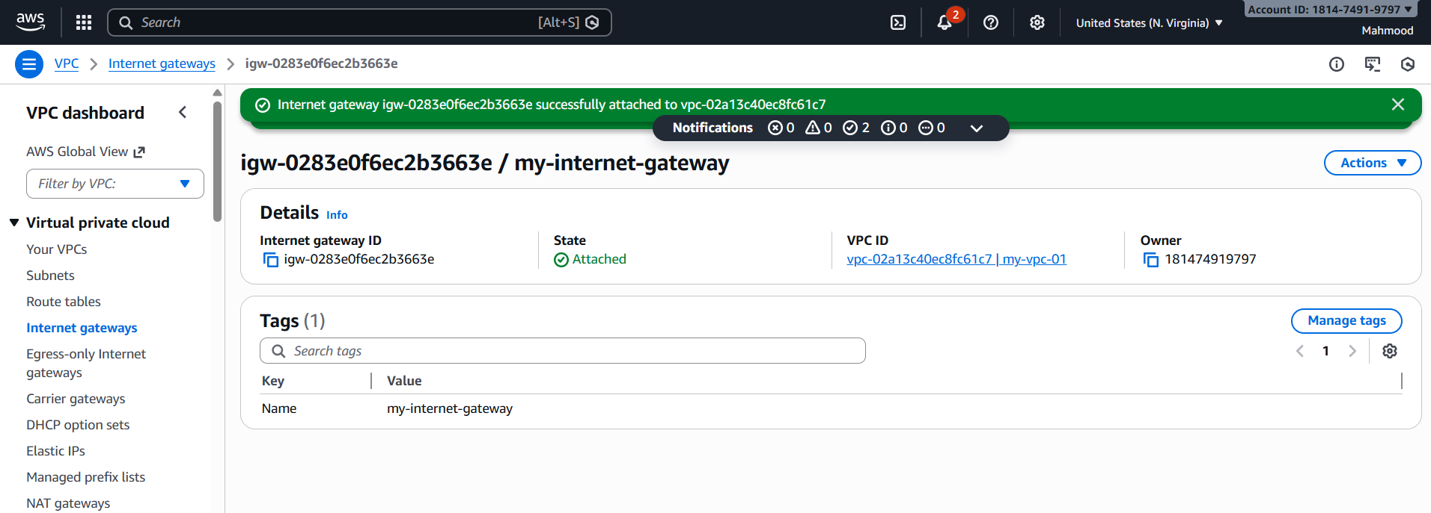  
Now we will provide the routes  
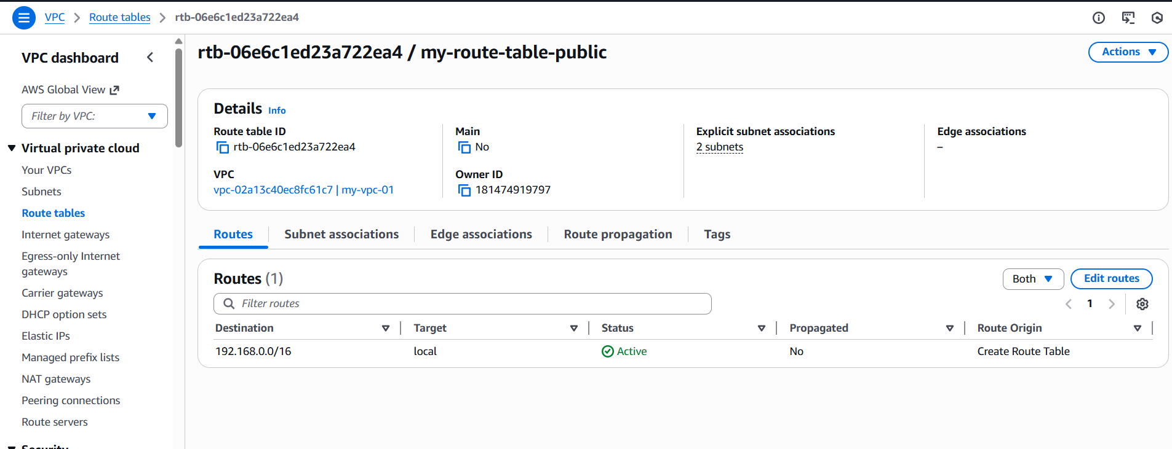  
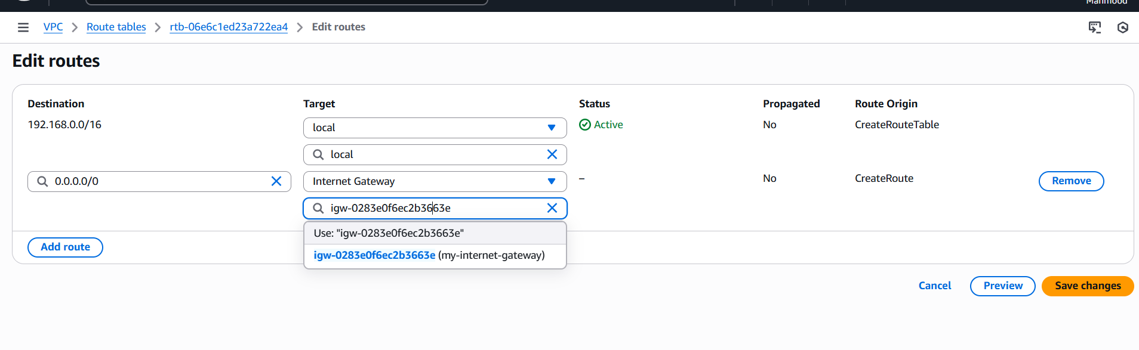  
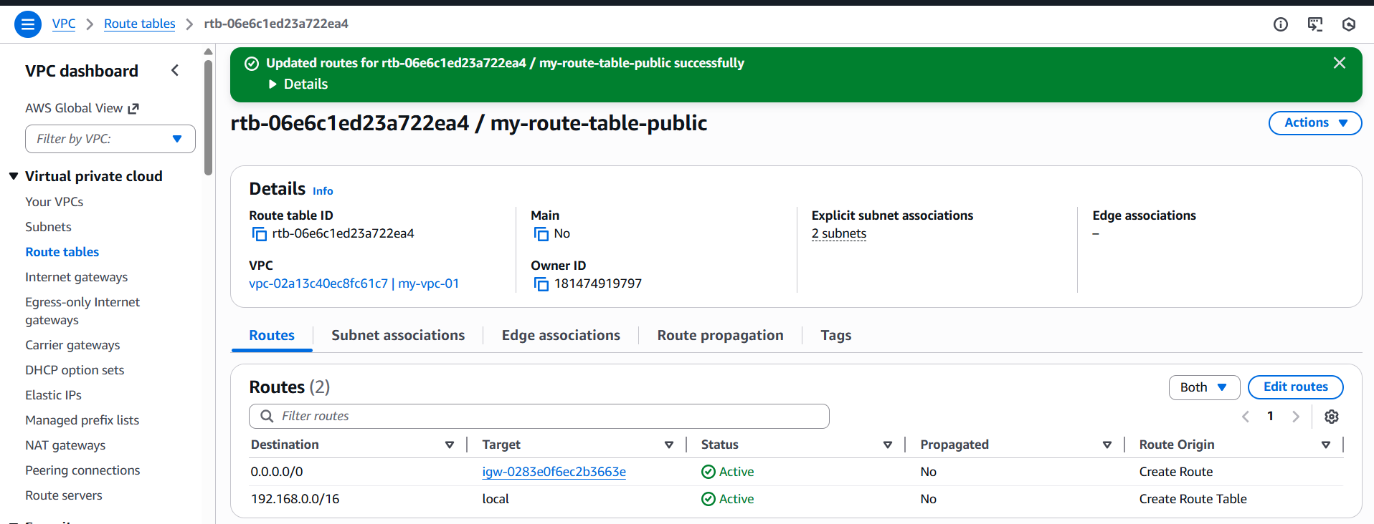

* Create EC2 in public subnet with t2.micro and install PHP  
  Firstly we need to launch instance with php-server and select AMI and t3 micro then select our vpc and select the public subnet  
  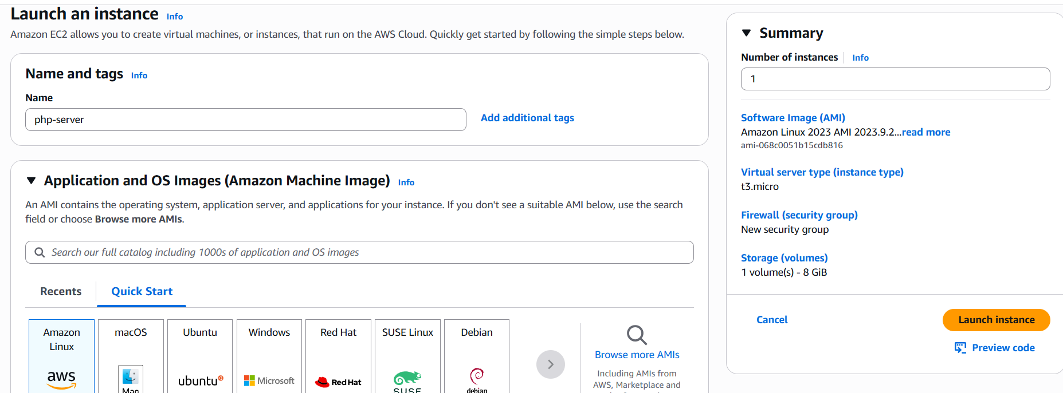  
  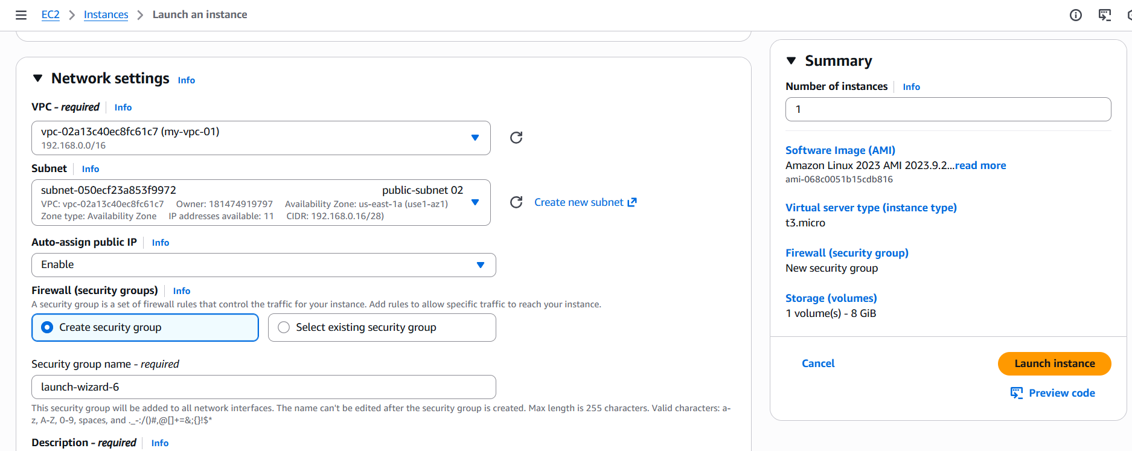  
  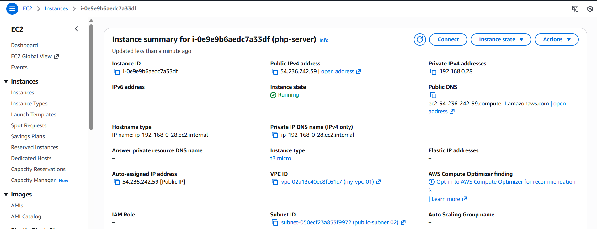  
  Now got to git bash and connect the server  
  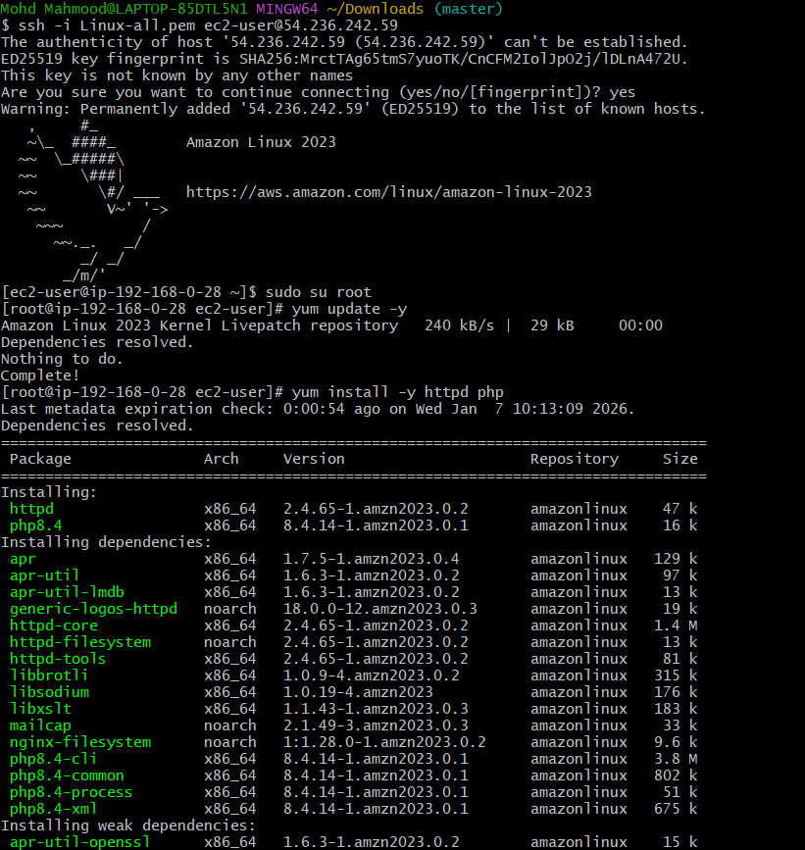  
  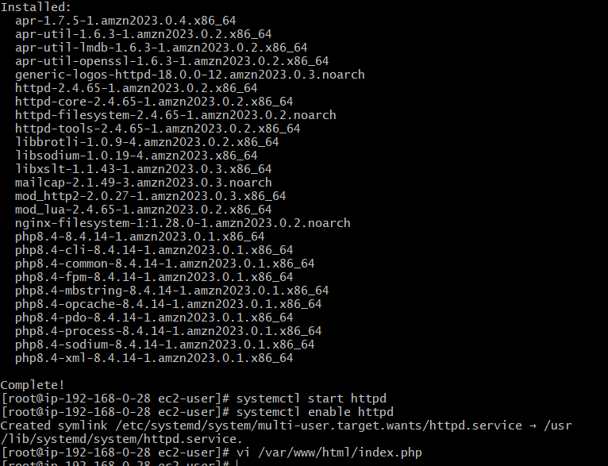  
  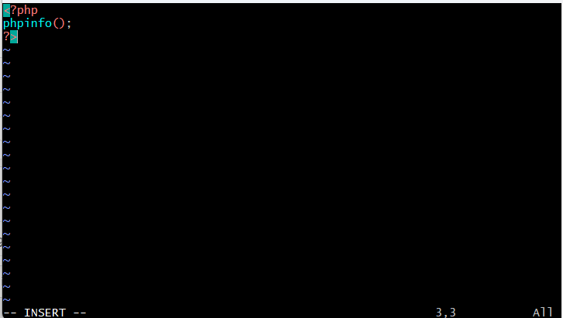  
  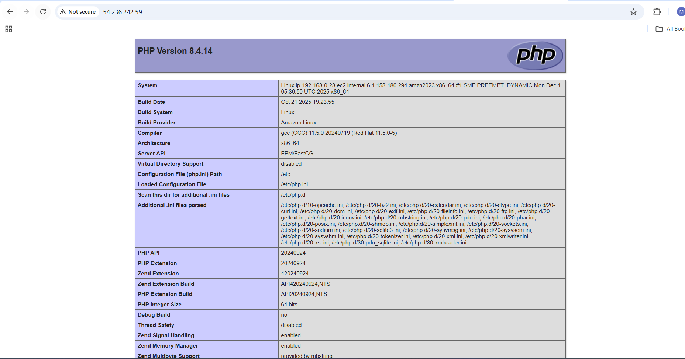
* Configure NAT gateway in public subnet and connect to private instance  
  Go to VPC and select Nat Gateway and select regional new and select manual elastic IP and click on allocate EIP then create it   
  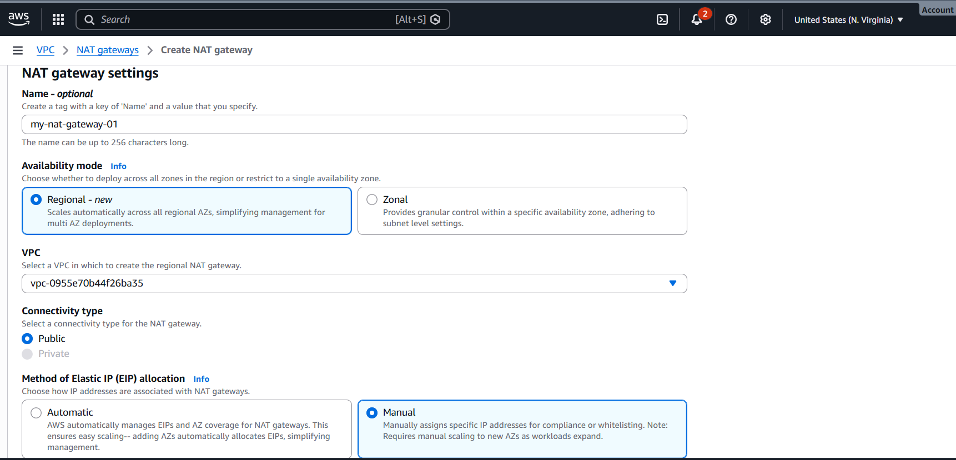  
  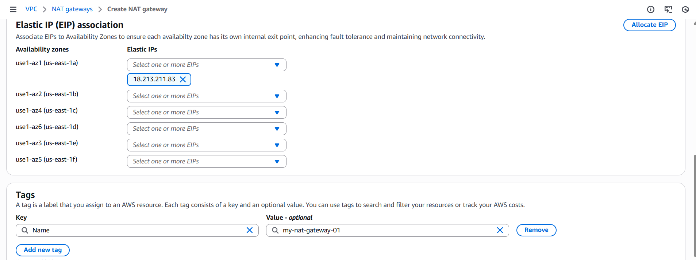  
  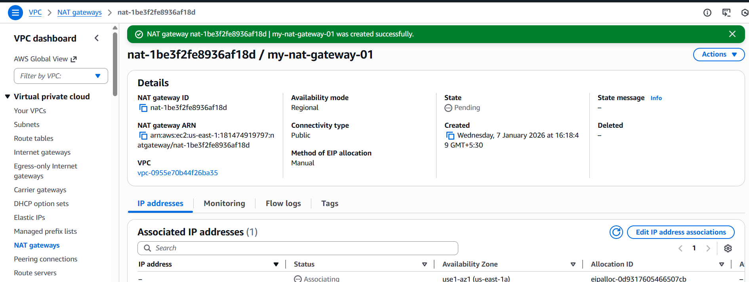  
  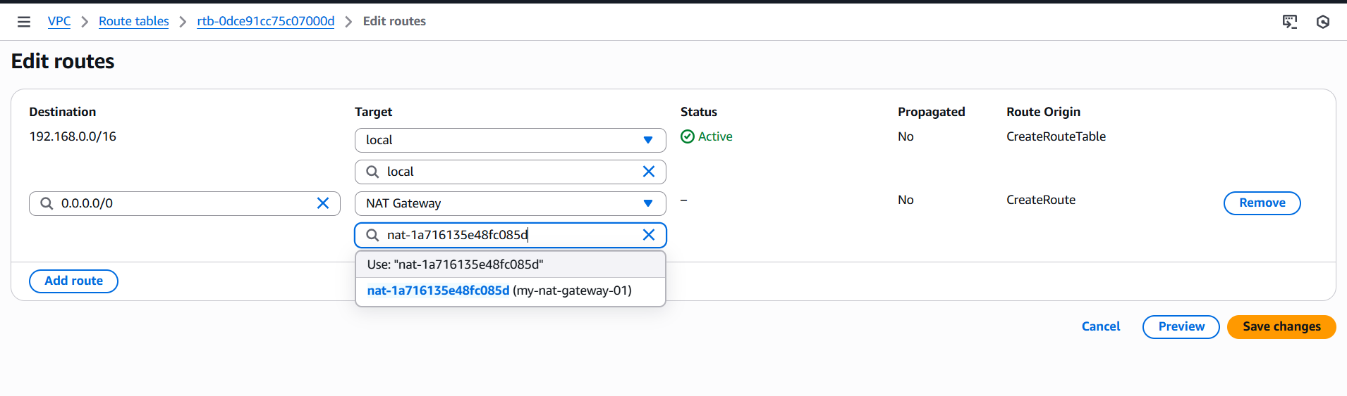  
  resource map by visiting VPC  
  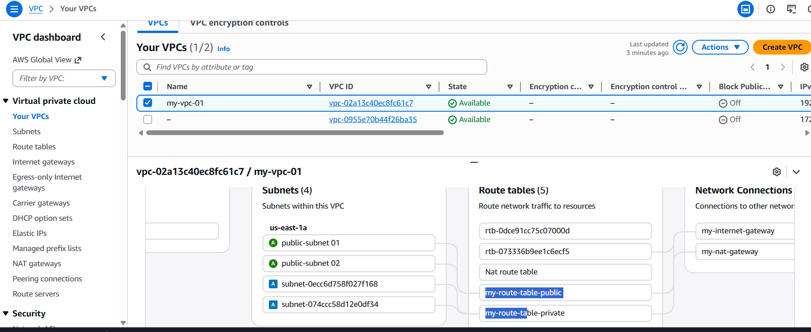  
  Now to login to ssh with public of instance of VPC connected  
  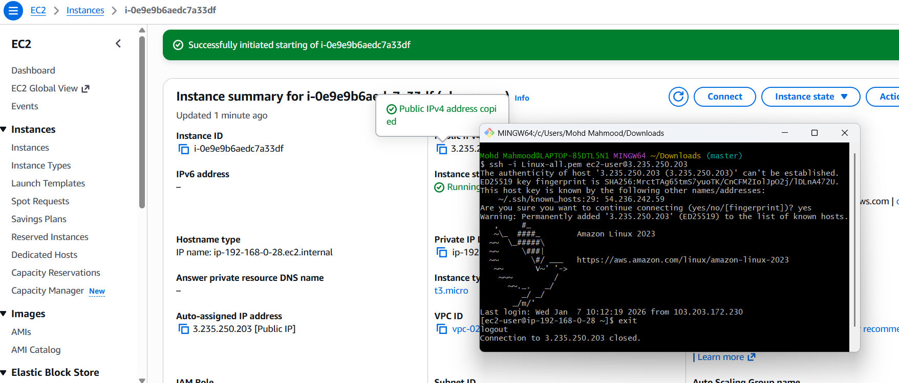  
  Instance is successfully connected with public ip and now we need to connect it with private ip  
  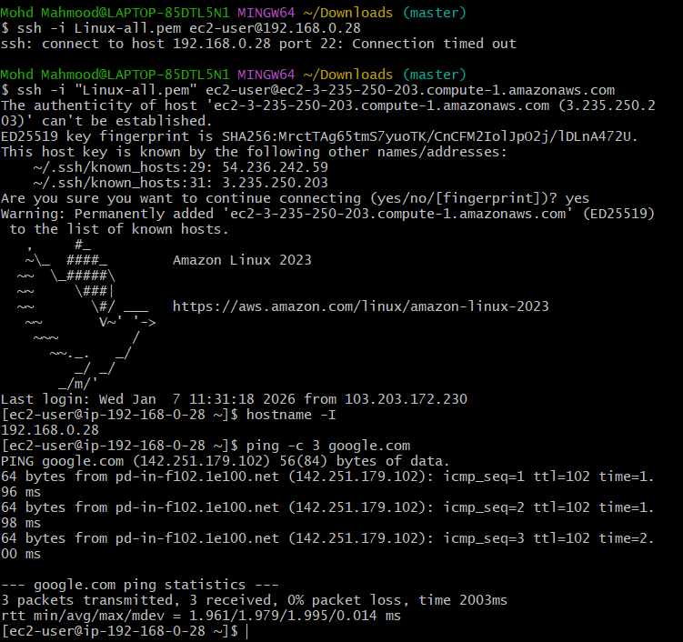
* Install Apache Tomcat in private EC2 and deploy a sample app  
  Connected to private EC2   
  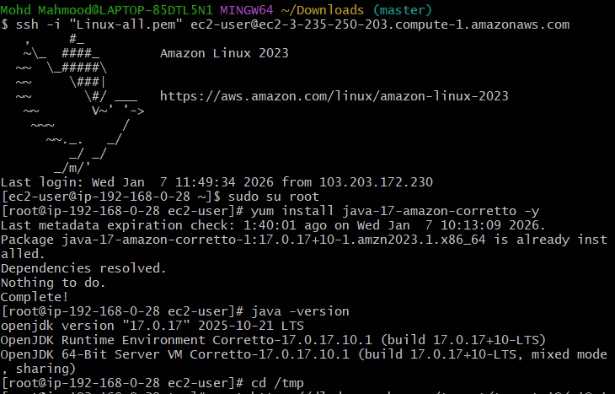  
  And installing the apache in sample app  
  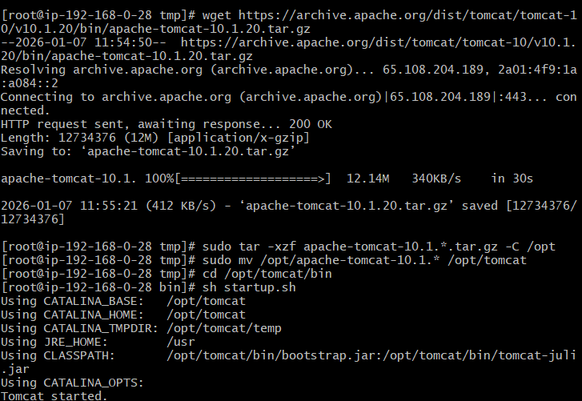  
  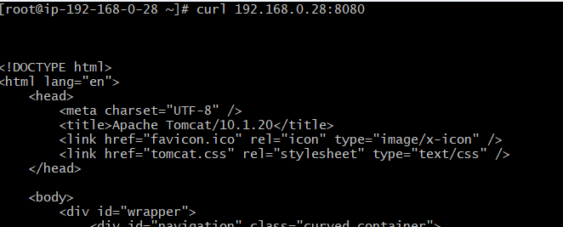
* Configure VPC flow logs and store the logs in S3 and CloudWatch  
  Firstly we need create S3 bucket   
  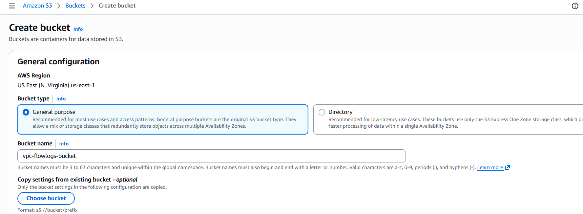  
  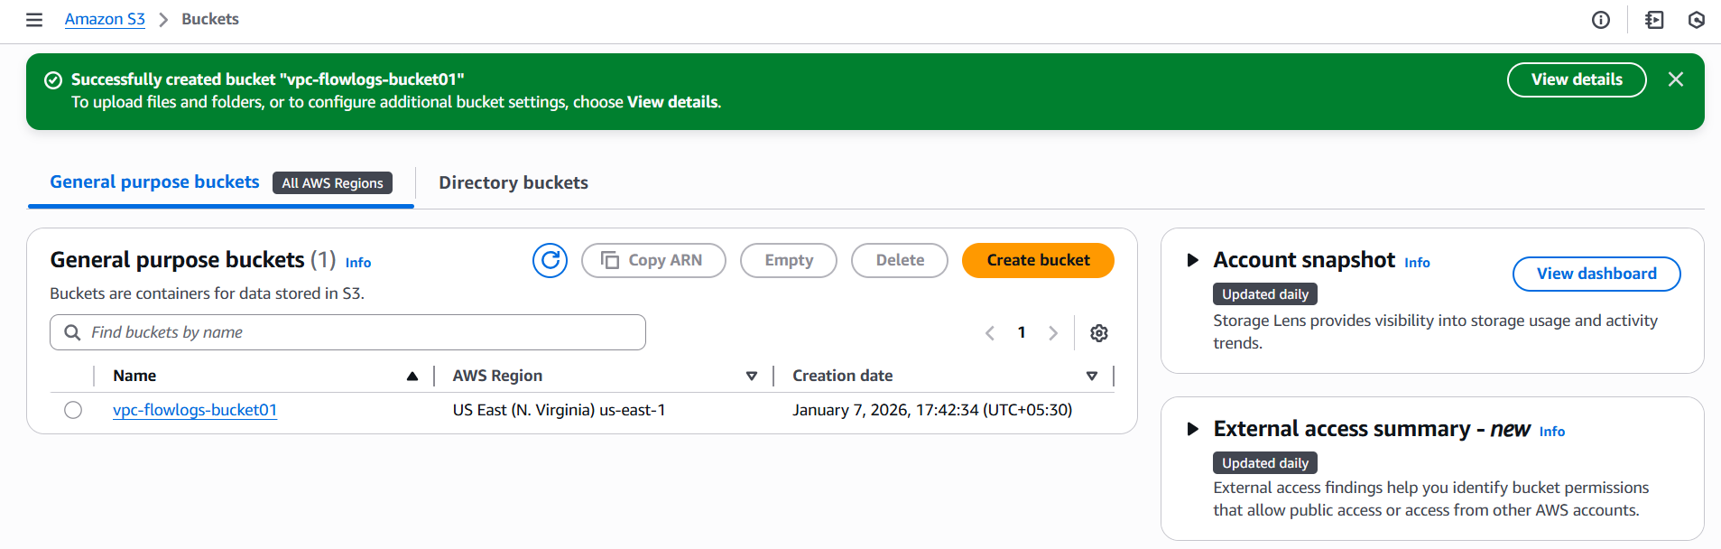  
  Now go to VPC and select our Vpc and go to actions select create flow log  
  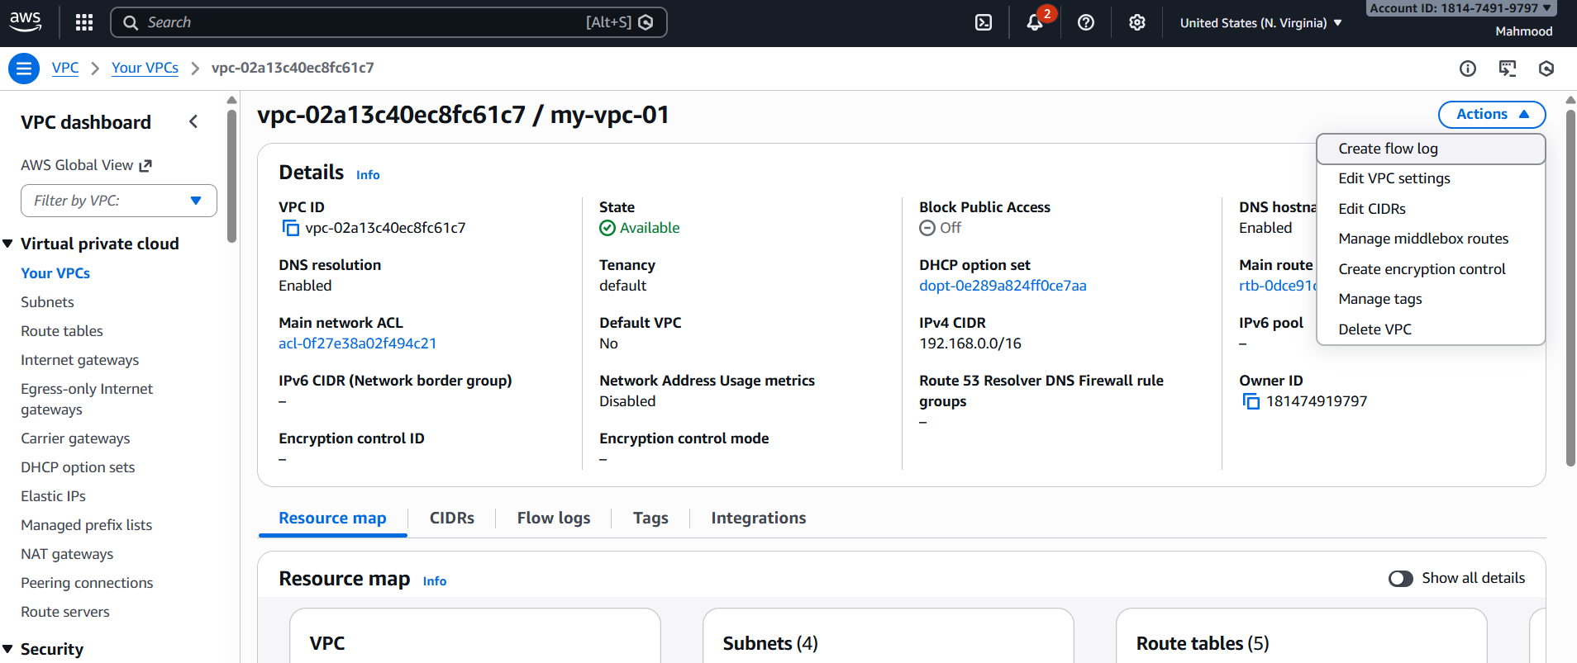  
  And create flow log   
  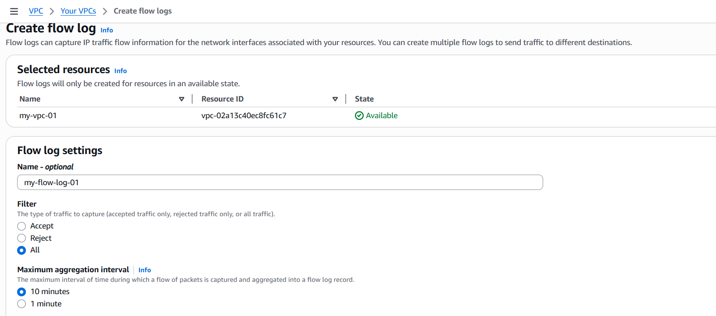  
  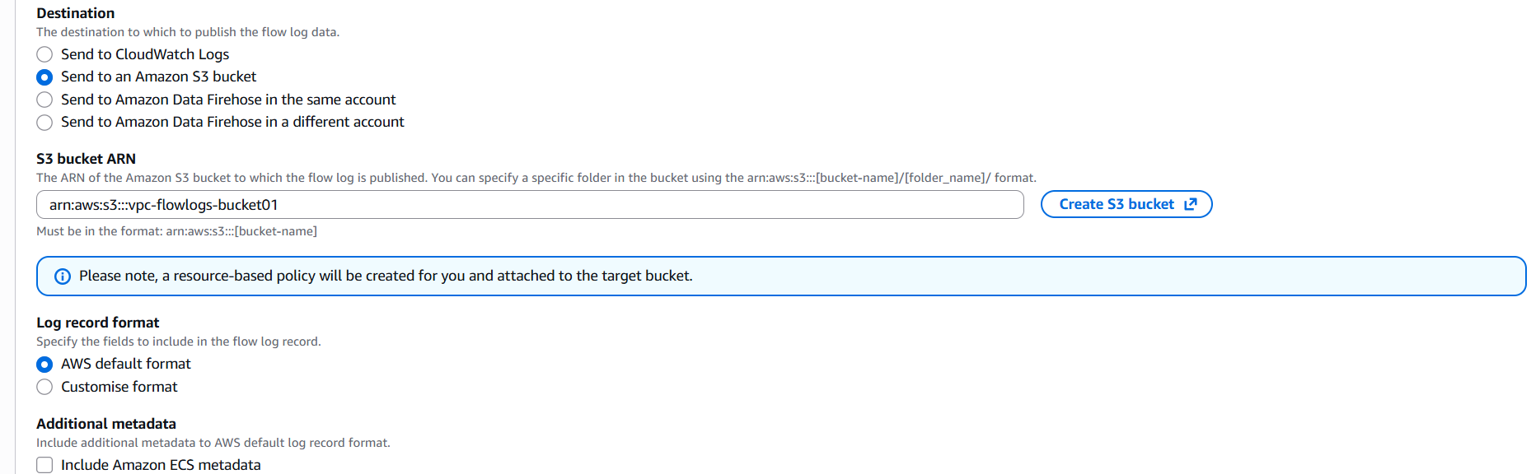  
  Click on create flow log  
  Now got to Cloud watch and create a log  
  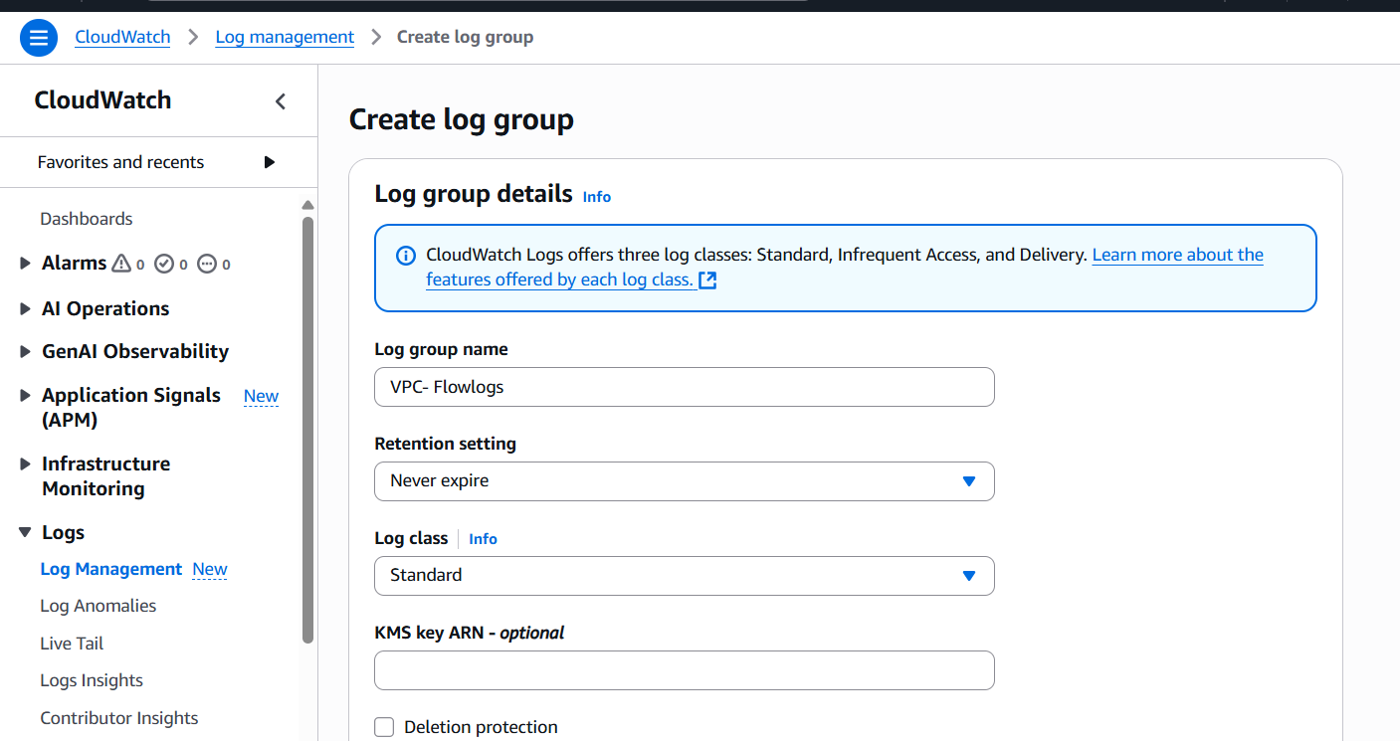  
  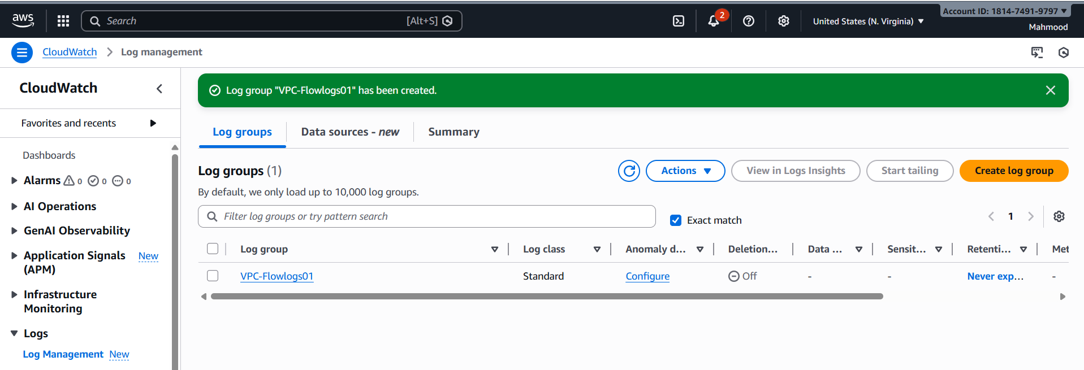  
  Now got IAM- roles-create role  
  